Projects cap school year disrupted by coronavirus and defined by remote learning

https://www.educationdive.com/news/habitats-baking-blogs-shoebox-theater-the-projects-capping-off-the-covi/578546
Teachers dedicated to the project-based approach have found distance learning brings "a larger range of what you’re willing to work through."
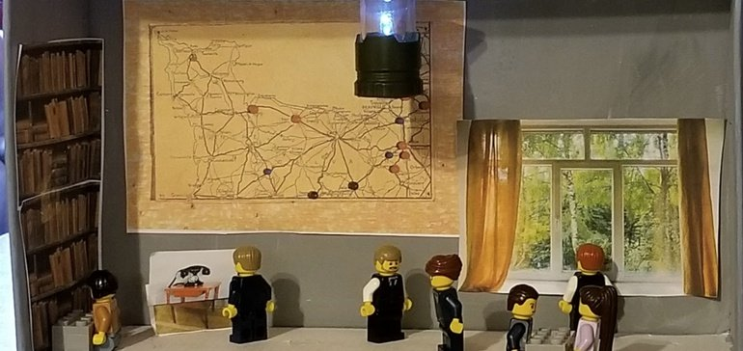
Permission granted by Mandy Stracke

By Linda Jacobson @lrj417

Published June 1, 2020

Ashley Jenkins’ kindergartners were just about to receive a visit from a petting zoo when their school closed because of the coronavirus. The special event was the kickoff for an animal habitat project usually conducted in class.
Jenkins, who teaches at the BIA Charter School in Norcross, Georgia, was planning on spending a week discussing mammals, birds and other animal groups. But now removed from her students, she had to adapt by creating a slideshow with a voiceover and reimagining how she could build the same knowledge for her young students that they would have gained at school.

“Even though the way we delivered content to students changed, the end goal of the project did not,” she said. “As a teacher I had to get creative and think about how I would [turn] these activities that I planned on making hands-on in class into something that students could access at home.”
Students watched BrainPopJr. videos and took virtual field trips to zoos to see actual habitats. Jenkins also used “choice boards” to give students — and parents — some direction on how to plan the projects.
“I really stressed to them that they did not have to go out and buy supplies,” she said. “They could use whatever they had at home, or even draw or use technology to create their habitats. One student used all materials from outside in her backyard.”
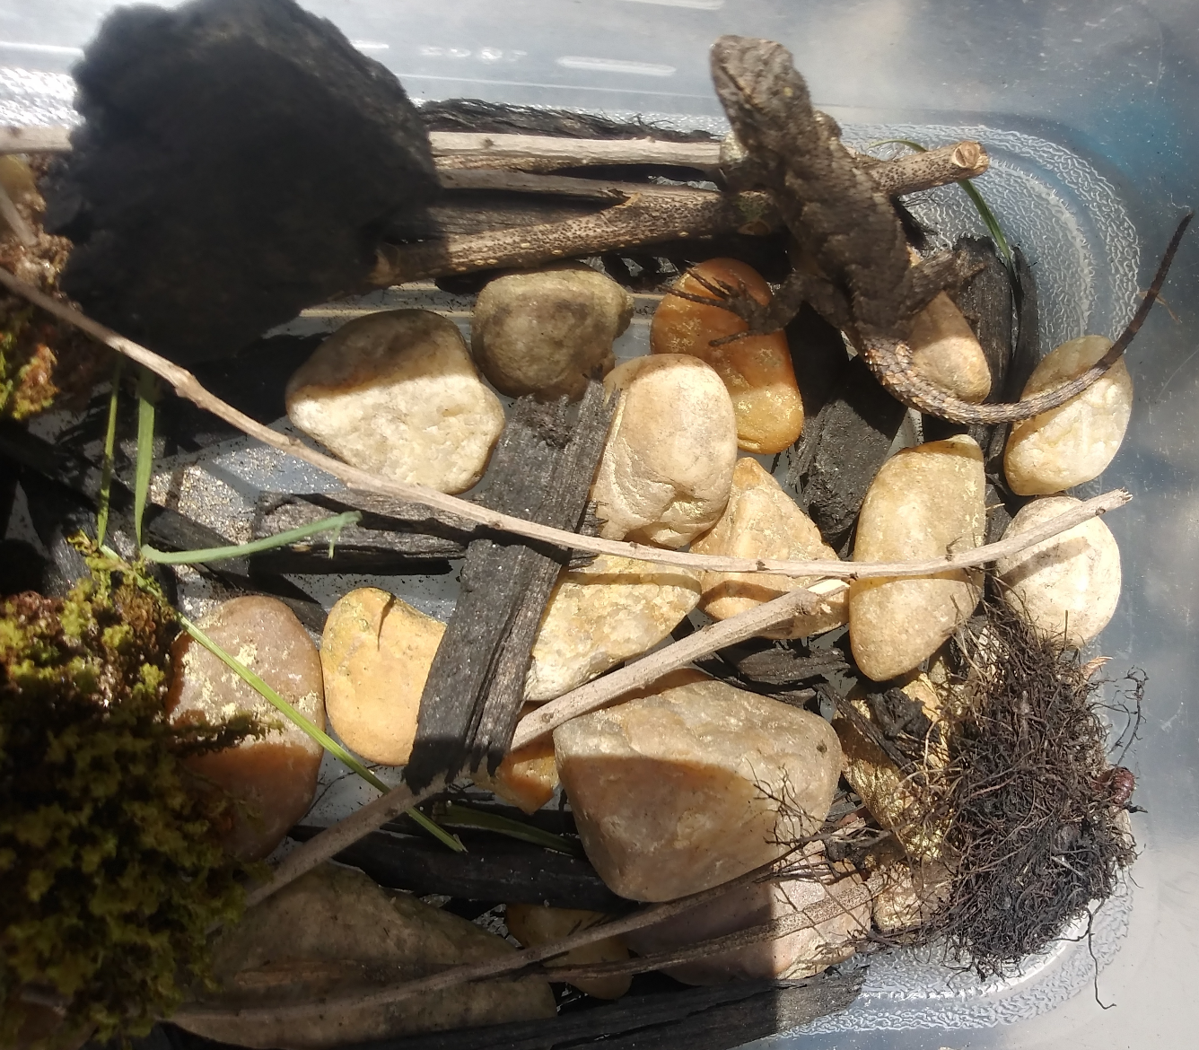
A kindergartner's reptile habitat.
Ashley Jenkins

'The puzzle' of how to end the year
There are teachers and schools that have long been dedicated to a project-based format — tying required content to larger themes, authentic experiences and students’ own interests. But some experts say this upended school year especially lends itself to open-ended assignments that require students to use some creativity and can even stand in place of a canceled assessment.
“They are tailor-made for teachers grappling with the puzzle of how to end the school year in an engaging and productive way,” American Federation of Teachers President Randi Weingarten said about the union’s Culminating Capstone Projects, posted this month on its Share My Lesson site.
And in just a week after the projects were posted online, they had been viewed or downloaded at least 10,000 times.
Others say the approach should be part of how educators redesign instruction this fall when students might be spending far more time learning outside of the classroom.
“The new opportunity that someone will figure out in the next two years is combining the benefits of robust asynchronous content with project-based learning,” Tom Vander Ark, CEO of Getting Smart, wrote in a commentary last week.
New Tech Network, a project-based school model that has spread to 200 schools nationwide, has received increased interest in recent weeks from districts and schools “communicating with greater clarity a strong ‘why’ for starting schoolwide project-based learning now,” said Kristin Cuilla, the network’s senior director of district and school development. “This sense of urgency reflects the shift in skills — agency, communication and collaboration — districts and schools realize students must have to be successful, especially when learning at home.”

In addition, PBLWorks, a nonprofit that provides professional development on the project-based approach, has also seen strong participation in its webinars. John Larmer, the editor-in-chief at the organization, said if students are rotating in-school attendance in the fall, as many re-opening plans have recommended, “doing PBL when they're home would make total sense.”

‘A little more weight’
Usually at this time of year, Juli Ruff, a 9th grade humanities teacher at the original campus of the High Tech High charter school network in San Diego, is guiding her students through three phases of the Forces of Change project.
First, they conduct research on people who have contributed to positive changes in the world. Then, they volunteer as part of local organizations — that’s the part disrupted when schools closed.
And for the final element, they are usually designing something that benefits the school community. Past examples have included a student creating an app with a virtual tour of the school, or another inviting top administrators of the network to talk to students about their positions. Projects usually involve other skills, such as essay writing or literary analysis.
Teaching from home, Ruff at first focused on providing students as much of a routine as possible, with a daily assignment and a deadline. Instead of taking the view that learning during a pandemic was overwhelming for students, she picked up that they were bored and needed “a little more weight to carry.”
In addition to having them analyze the short story “The Lady, or the Tiger?”, Ruff redefined the third phase of the project to focus on something beneficial that students could do at home. One planned to create a baking blog. Another pitched soccer instructional videos, and one girl proposed reading daily Bible passages to her grandmother, who hasn't been able to get her new eyeglasses prescription, over the phone.
The students also have to submit a Google slide or other evidence of the work that went into their project.
Ruff said she agrees some students might need additional emotional support depending on how their family has been affected by the coronavirus, but “we need to not lament that life threw us a curve ball. We have to learn to hit a curve ball.”

Competing pressures
There are also reasons, however, why schools might now be less inclined to pursue project-based learning, Larmer said.
The first is school districts are headed into a financial stretch that could be worse than the Great Recession, which could impact professional development opportunities. The second, he said, is “some states and districts might think it's time to go ‘back to basics’ because that's all they think teachers can do, given the unsettled and new reality,” or because students will need to “catch up on missed time.”
A significant study on project-based learning in science, however, showed the approach “can help close the learning gaps among students of underrepresented demographics in STEM courses and level the field between girls and boys,” according to a summary of the study. Students using the project-based materials “outperformed students in the comparison curriculum on outcome measures that were aligned to core science ideas and science practices,” the researchers wrote.
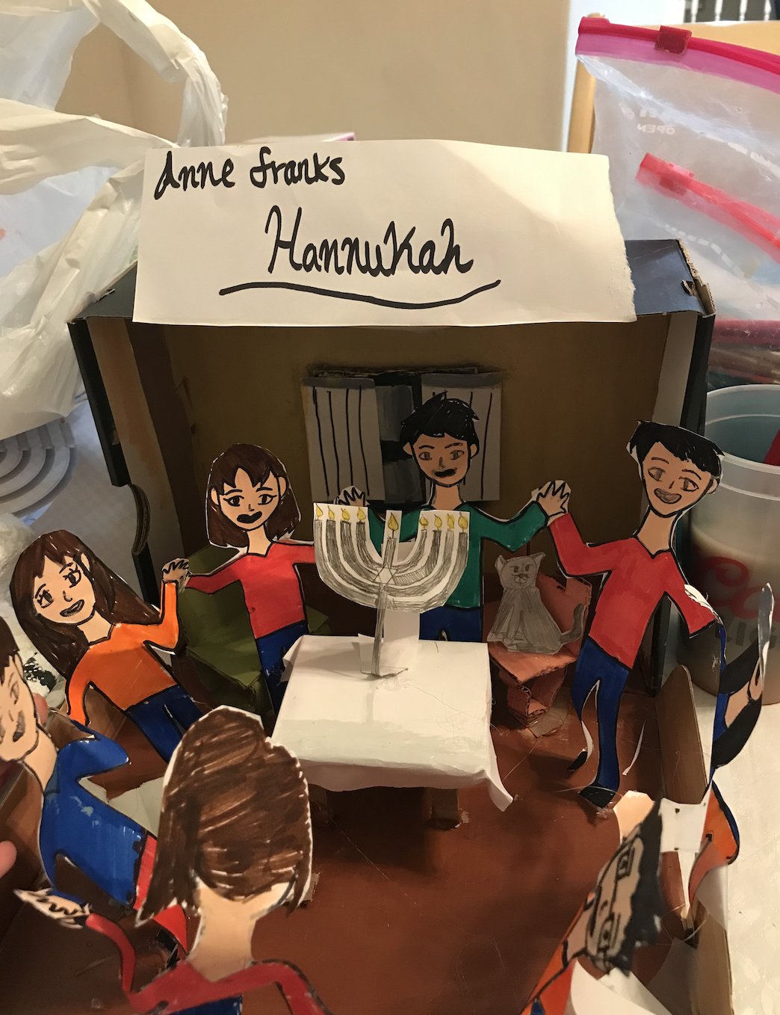
A student's representation of a scene from "Anne Frank: The Diary of a Young Girl."
Mandy Stracke

Even so, trying to recreate a project-based assignment students could successfully complete at home left even committed project-based educators with some doubts.
When schools closed, 8th-graders in Mandy Stracke’s project-based history and English language arts class were in the middle of a "Fulcrum of History" project and considering the question: In what ways have the drivers towards and facets of war changed or remained the same in the modern era?
For ELA, they were using “Anne Frank: The Diary of a Young Girl,” and in history, they were studying the Civil War. She decided to offer her students the choice of either a traditional or project-based track because she felt constrained by having a two-hour time limit with them each week.
“I should have stuck to what I believed in … and just offered the [project-based learning] track. Now that we are in the middle of the project, I know that we could have made it work,” said Stracke, who teaches at the New Tech Network-affiliated Lobo School of Innovation at Quimby Oak Middle School in San Jose, California.
In school, they would have been creating a museum exhibition for other students to view. For distance learning, Stracke substituted a “shoebox theater” or a piece of artwork. Shelter-in-place journals and book talk videos were also elements of the assignment.
At Roger Bell New Tech Academy in Havelock, North Carolina, teachers were in their first year of implementing a project-based approach. While some teachers had to end their projects when schools closed, others were able to adapt them to be completed at home. Fourth-graders, for example, continued their Improving Our Skies project, focused on the history of flight and technological innovation, by creating videos on force and motion to show their understanding, said Caroline Godwin, a curriculum coach at the school.
Math teachers also introduced some real-world projects. Fifth-graders met with an interior designer over Zoom and were challenged to measure their rooms, plan a budget and then redesign their own spaces.

“We need to not lament that life threw us a curve ball. We have to learn to hit a curve ball.”
Juli Ruff
9th grade humanities teacher, High Tech High

Teaching skills that ‘stick’
Teachers say the same factors that influence students’ completion of traditional assignments during distance learning also apply to projects. Some families lack reliable internet, which, Jenkins said, makes it hard to check in on their progress.
As in the classroom, there is also a wide range in how many details students will add to their projects or how thoroughly they will try to demonstrate what they learned. “Some students kept to the minimum,” Stracke said, “while others went out of their way to hand-sew costumes for handmade characters in order to truly re-create that scene.”
Godwin notes another limitation in transitioning projects to remote learning is some students lacked familiarity with iPad apps. Next year, she said, teachers will take a more "blended approach" to projects to give students more practice with apps "used to research, collaborate and create products."
Jenkins said having the students work on their habitats at home gave them some practice in “planning and creating and maintaining their own work schedules. These are skills that hopefully will stick with them in the future.”
A review of research on project-based learning, conducted about 20 years ago, suggested students often have difficulty in “self-directed situations,” such as managing their time, initiating the questions their project will answer and using the right technology. While students are far more skilled with tech tools today, the authors wrote for project-based learning to be effective, it’s important to build in “a range of supports to help students learn how to learn.”
Stracke said she also noticed students who are usually quiet in class “are now regular contributors to our online video call sessions.”
She added she’s now thinking about “how to up my PBL practices to be closer to gold standard, but also to revamp my thinking about how to approach the different parts of the project path, looking toward a future where we may or may not need to blend distance learning with in-person learning."
Remote learning “changes the way the projects can look,” Ruff said. However, she added it’s “important not to lower the bar, but to have extra compassion. There’s a larger range of what you’re willing to work through.”
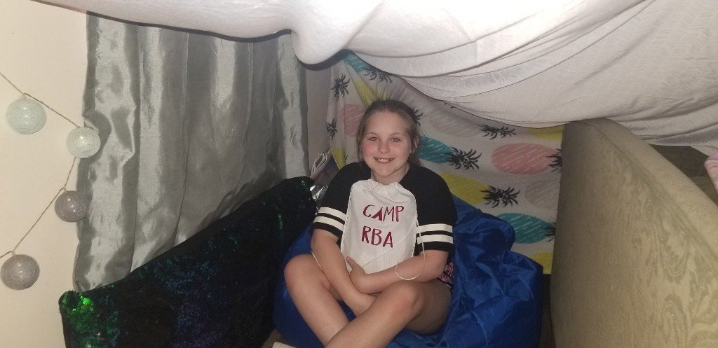
A 5th-grader at Roger Bell New Tech Academy redesigned her room as part of a distance learning math project.
Caroline Godwin

